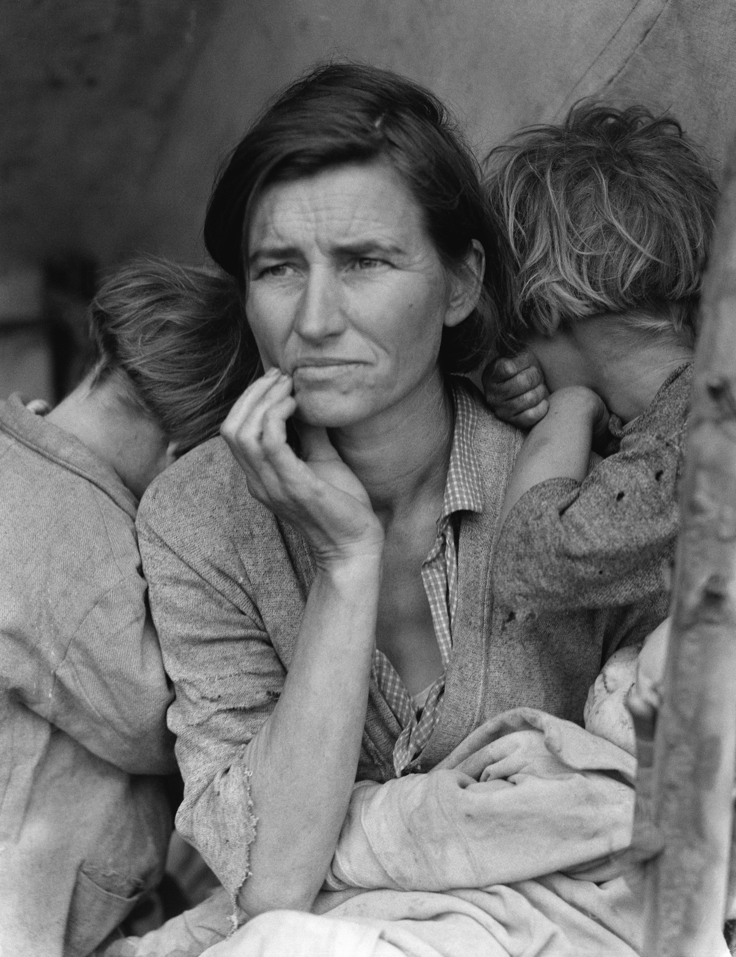

Dorothea Lange
Migrant Mother
1936

Steve McCurry
Afghan Girl
1984

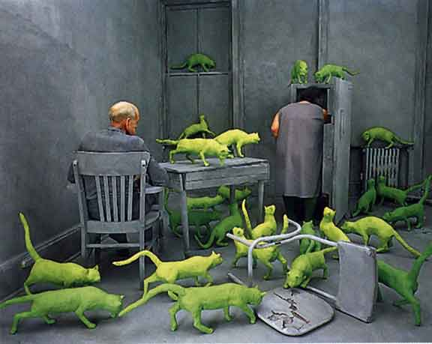

Sandy Skoglund
Radioactive Cats
1980

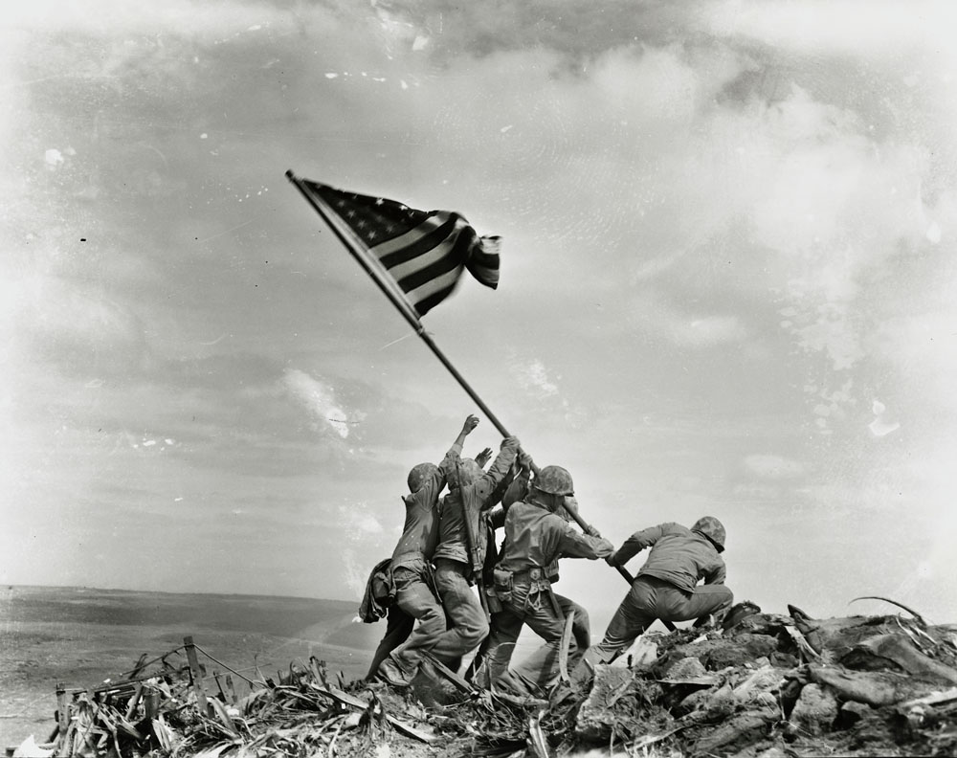
Joe Rosenthal
Iwo Jima
1945

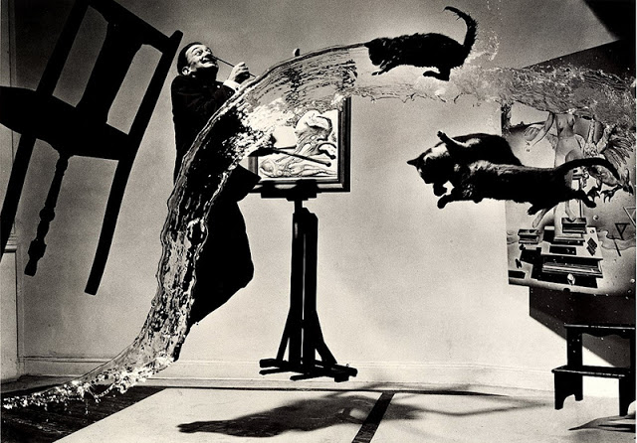
Philippe Halsman
Dali Atomicus
1948

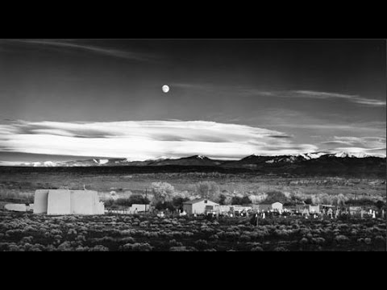
Ansel Adams
Moonrise over Hernandez, New Mexico
1941
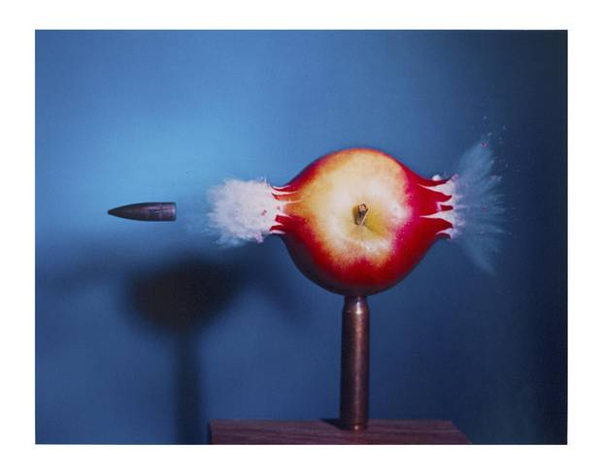
Harold Edgerton
Bullet Piercing an Apple
1964

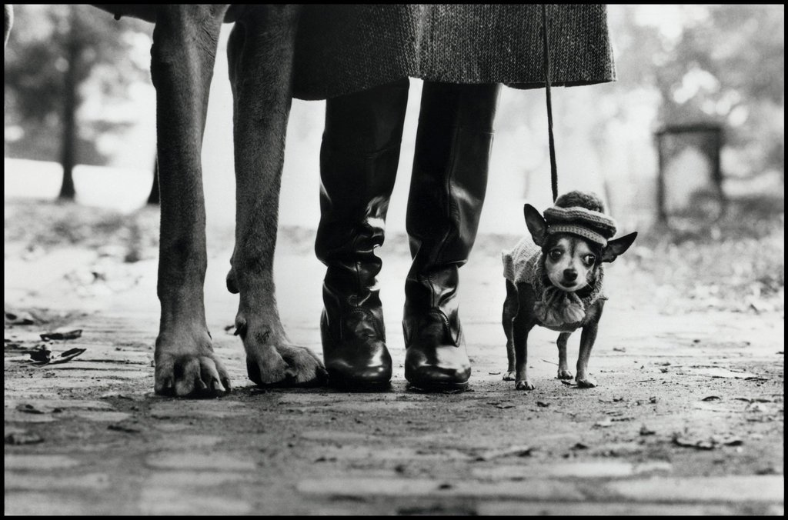

Elliot Erwitt
New York City
1974

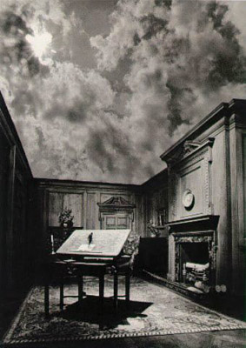

Jerry Ueslmann
Untitled (Man Standing on Book with Sky Ceiling)
1976

